Lab 3

Nguyễn Thanh Hoài Lộc – SE151250

# Requiring

* Kali Vm
* Win 10 Cm

# Setting Kali VM

* Setting kali to Vmnet3 mode

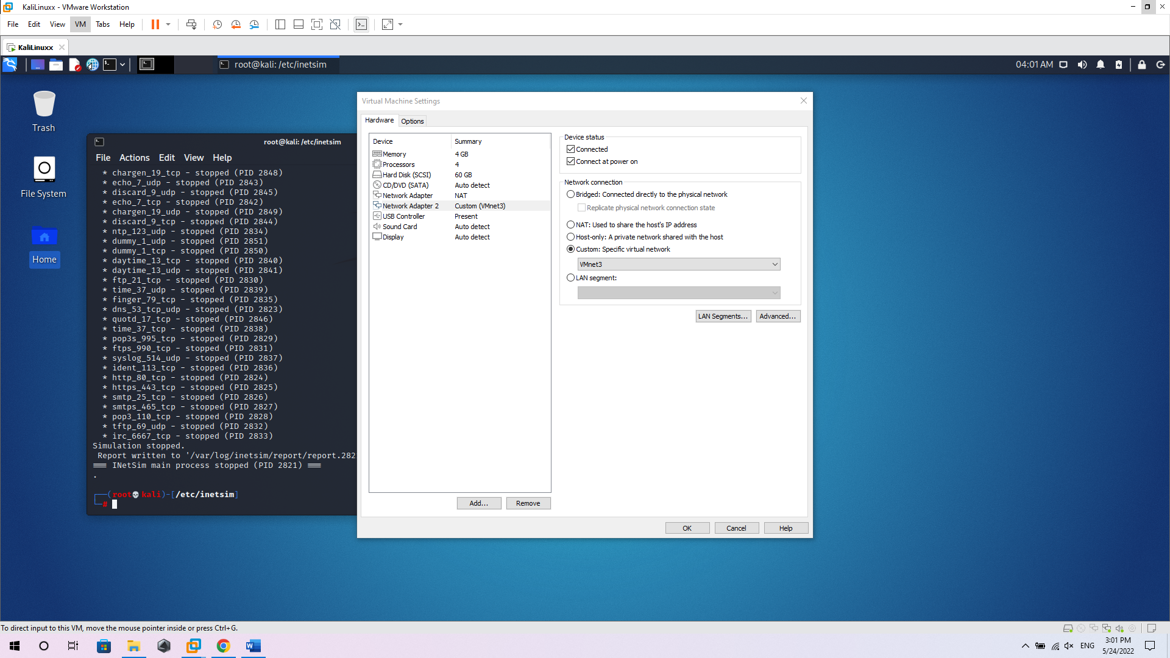

* Setting the kali ip address

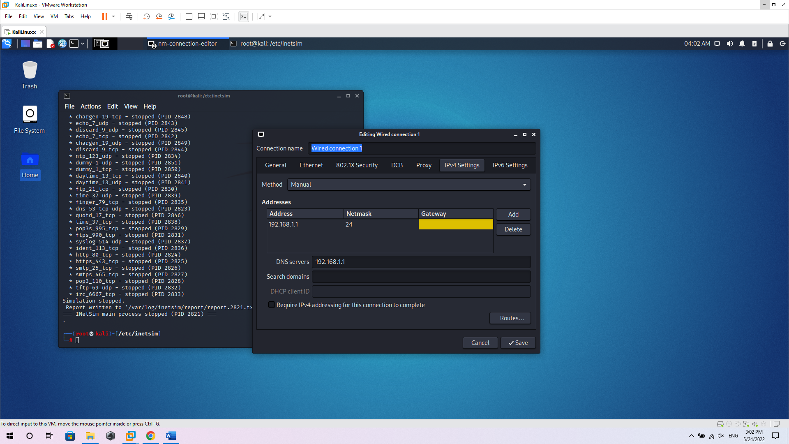

* Configure inetsim

cd /etc/inetsim

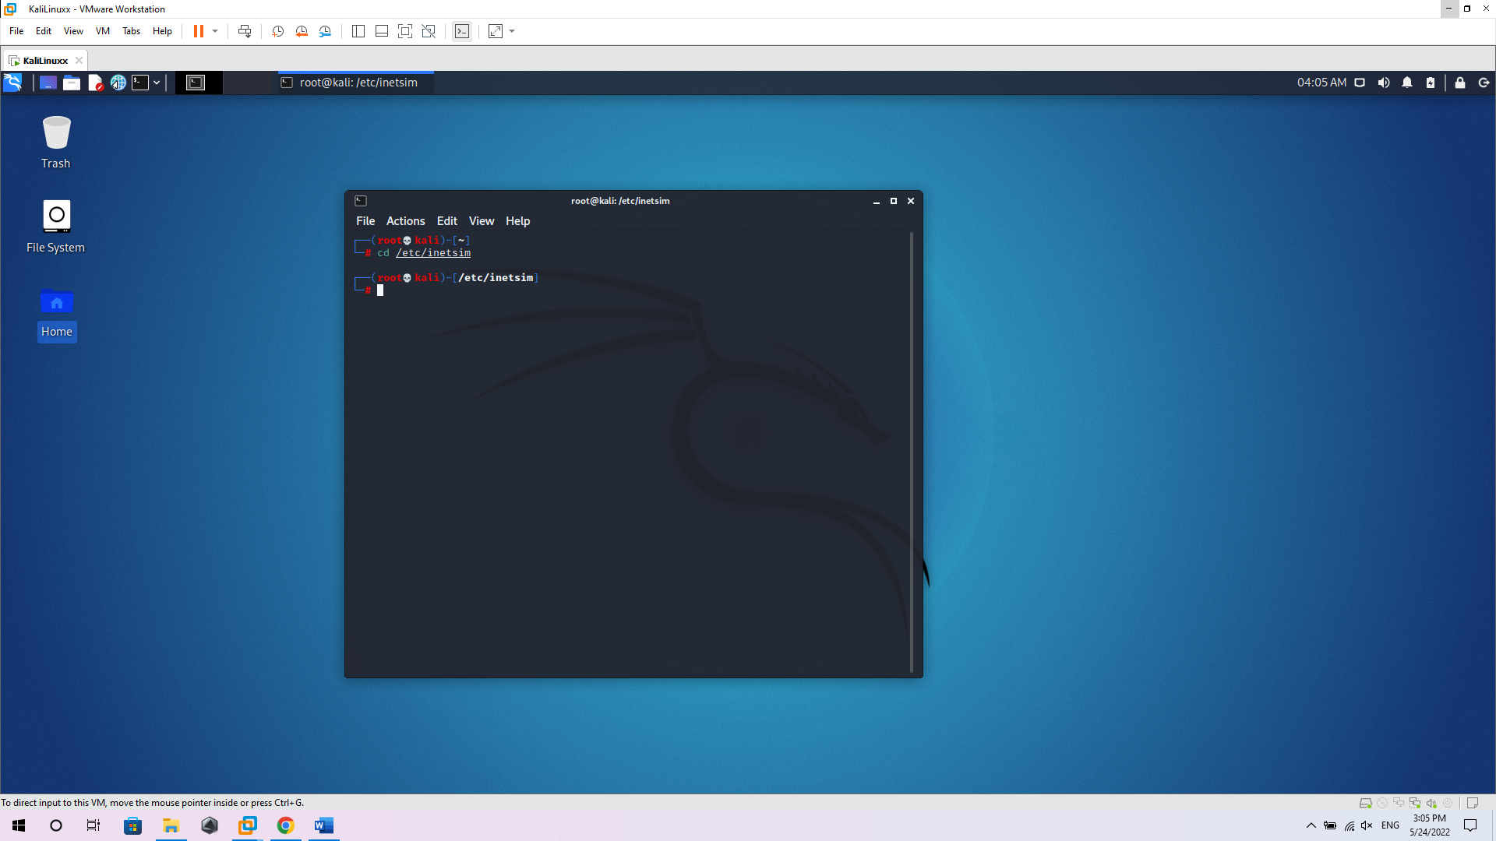

cp inetsim.conf inetsim.config.bk

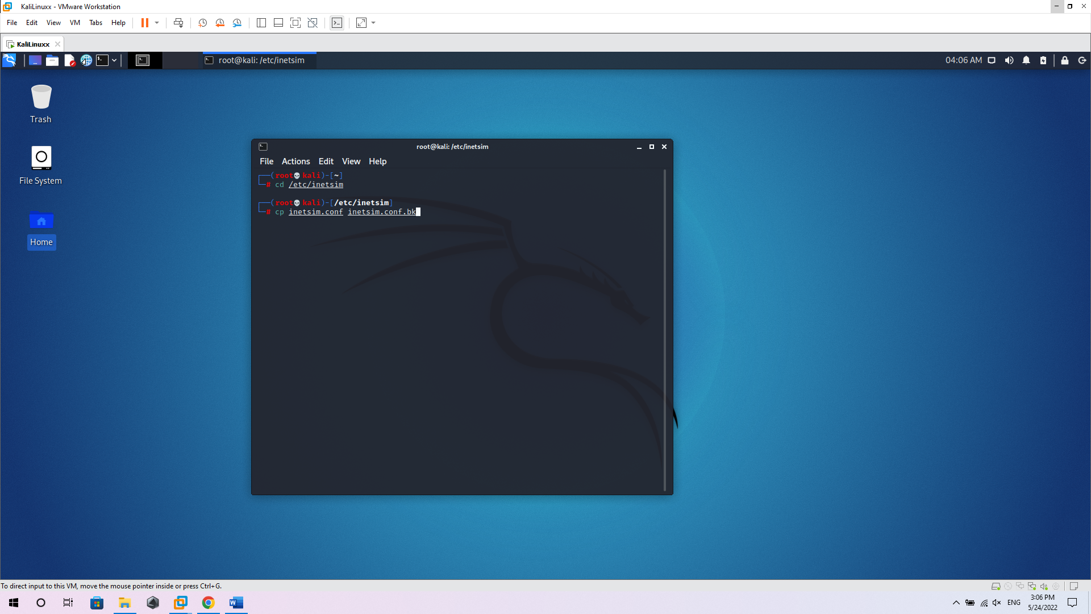

nano inetsim.conf to change:

* service_bind_address 0.0.0.0
* dns_default_ip 192.168.1.1

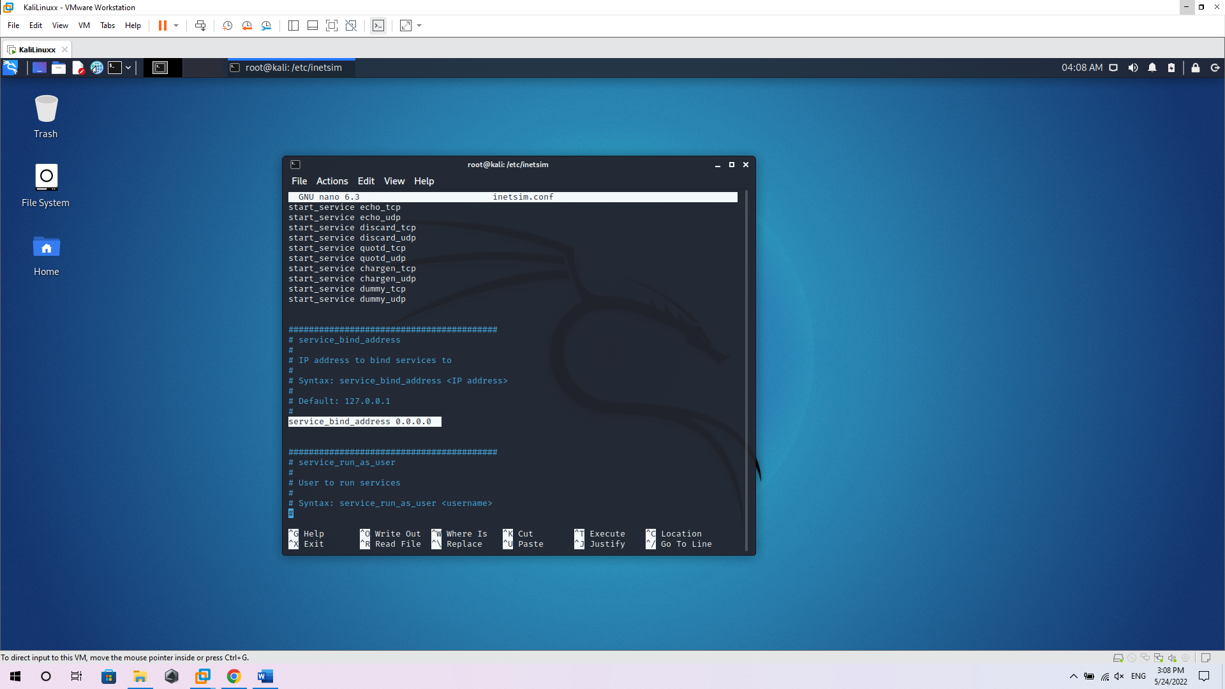

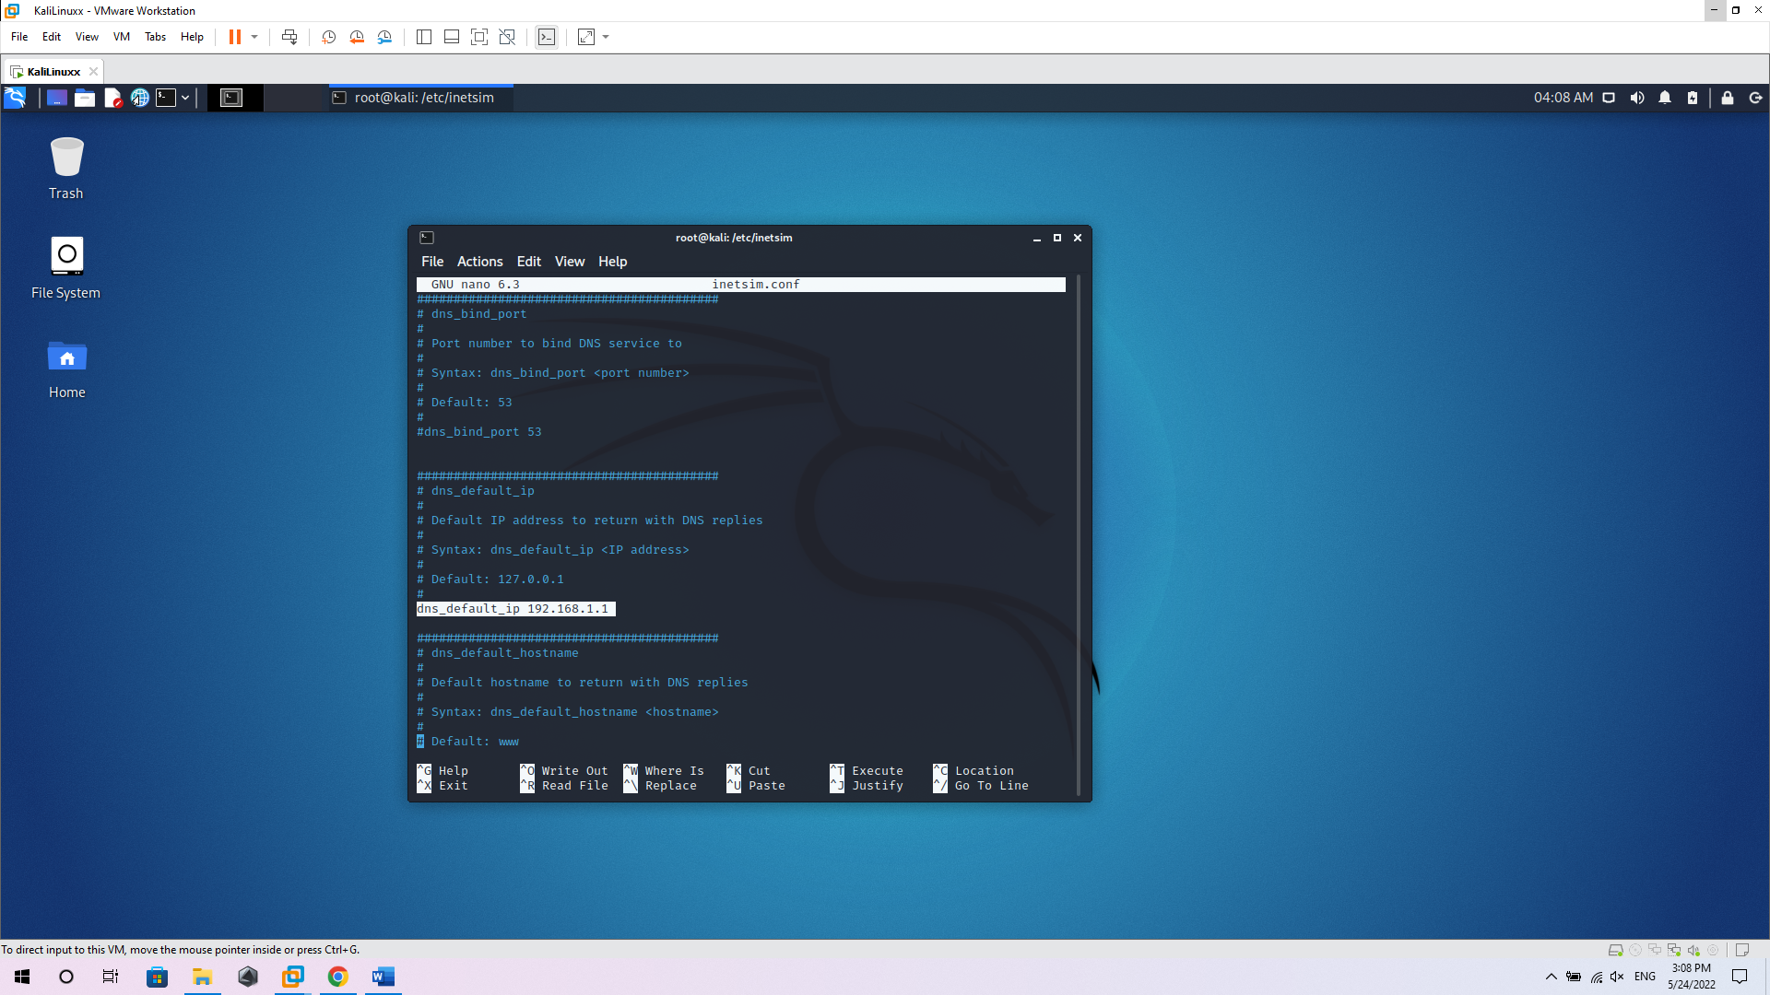

# Setting Win VM

* Setting kali to Vmnet3 mode

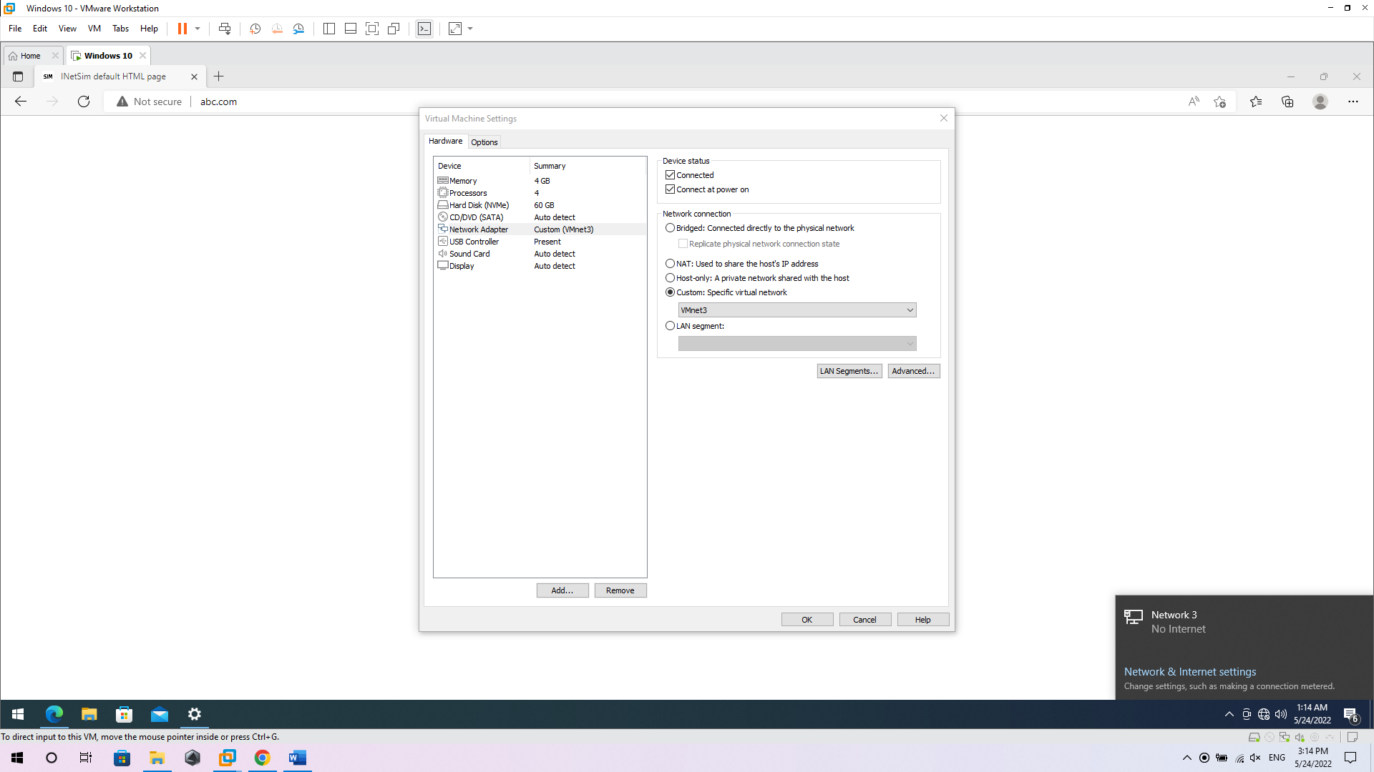

* Setting win IP. Dns

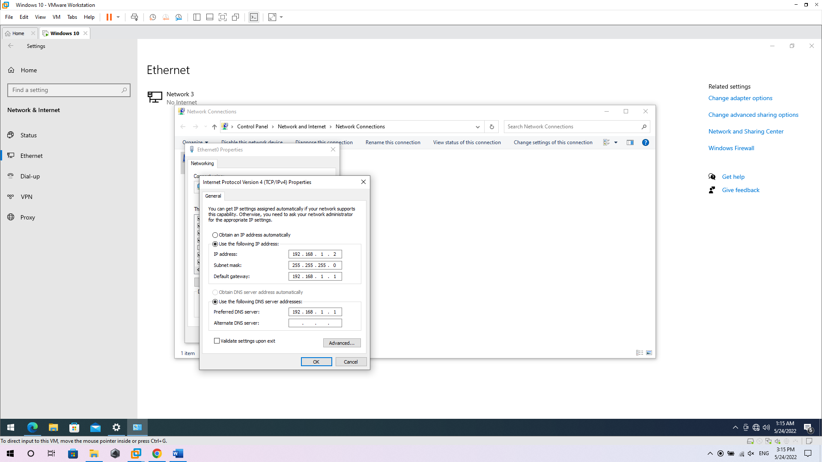

* Ping to any name domain:

loc.com, looc.com, loooc.com

